[**Paper Prototype (Figma)**](https://www.figma.com/proto/Cn2Y3KaMF6QJdYePcs0FAF/the-sound-room_paperPrototype?page-id=0%3A1&type=design&node-id=1-14&viewport=934%2C642%2C0.13&t=sXi3EbFL2gwOQmgF-1&scaling=min-zoom&starting-point-node-id=1%3A14&mode=design)

On-boarding, Home Page, Profile

[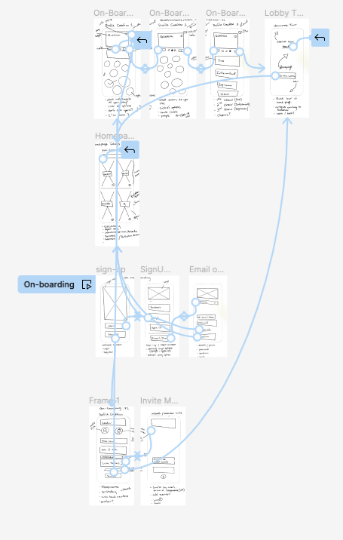](https://www.figma.com/proto/Cn2Y3KaMF6QJdYePcs0FAF/the-sound-room_paperPrototype?page-id=0%3A1&type=design&node-id=1-14&viewport=934%2C642%2C0.13&t=sXi3EbFL2gwOQmgF-1&scaling=min-zoom&starting-point-node-id=1%3A14&mode=design)